StrokeGuard: Stroke Prediction System

Abstract
Stroke is one of the leading health issues in the world today. Every year, a large number of people either lose their life due to stroke or end up living with permanent problems like difficulty in walking, speaking, or even remembering things. Doctors and hospitals do provide treatments, but the truth is that preventing a stroke before it happens is far more effective than treating it after it occurs. The biggest challenge is that most people don’t even know they are at risk until something serious takes place.
In this project, I have worked on StrokeGuard: Stroke Prediction System, which is designed to predict the chances of a person getting a stroke by studying different health-related factors. The system uses machine learning techniques where data such as age, blood pressure, sugar level, medical history, smoking habits, and other details are taken into account. By training the model on past patient data, the system learns the patterns which can later help in predicting the possibility of stroke for new patients.
The main goal of this project is to give people an early warning so that they can take preventive steps on time. For example, if a person finds out that they are in the high-risk category, they can go for regular checkups, improve lifestyle habits, or consult a doctor before things get worse. In the future, such a system can be made available as a mobile app or in hospitals to make it easy for anyone to use. Overall, StrokeGuard is a small but meaningful step towards reducing the risk and burden of strokes with the help of technology.

Introduction
Stroke is a serious medical condition that happens when blood flow to the brain is blocked or reduced. Without enough oxygen, brain cells start to die within minutes, which can cause permanent damage. For some people, stroke leads to death, and for others it results in long-term problems like paralysis, memory issues, or difficulty in speaking. According to global health reports, strokes are among the main reasons for death and disability worldwide. This shows why it is very important to find out who is at risk before the situation becomes critical.
Most doctors today try to identify stroke risk using common medical factors like age, high blood pressure, smoking, or diabetes. But in real life, stroke risk is not caused by just one factor, it usually comes from a combination of many things. For example, a person with both hypertension and high sugar levels might face higher risk than someone with only one of these. Traditional methods often fail to properly calculate this combined risk. This is why the use of technology becomes very useful here.
The project StrokeGuard is my attempt to use machine learning for solving this problem. The system is trained on health data where different features such as lifestyle, medical history, and test results are provided. By learning from these records, the model can identify which set of factors are more likely to result in a stroke. Once trained, StrokeGuard can take new patient details and predict whether the person has high, medium, or low risk of stroke.
The special thing about this project is that it focuses on prevention. Instead of waiting for a medical emergency, StrokeGuard provides an early signal. If such a system is used in clinics, hospitals, or even as a mobile tool, it can help common people monitor their health regularly. For example, a working professional who doesn’t get time for frequent checkups can still know their stroke risk through this system and take action early.
Another important point is that stroke treatment and recovery are very expensive and require a lot of resources. By reducing the number of stroke cases through prevention, both families and healthcare systems can save time, money, and effort.
In conclusion, StrokeGuard shows how technology and healthcare can work together. It uses data and machine learning not just for prediction but also for creating awareness and saving lives. As a B.Tech project, this work gave me the opportunity to understand how real-world problems can be addressed using simple but effective technical solutions. The bigger vision is to improve this model further and make it more accurate and user-friendly, so that it can reach more people in the future.

Literature review
The literature review helps us understand that what kind of work has been done in the area of stroke prediction and how their studies can make us understand the development of our project work. It provides useful information into the different approaches, technologies, and ideas that the other researchers have used to predict strokes and reduce the risk for stroke. Stroke has been one of the major causes of death and disability all over the world for many years. Because of this, lot of research has been done to find out its root causes and to design methods that can help in early prediction and prevention.
In the past years, technology has become one of the most important part in the medical field. With the quick growth of computer science, ideas like Artificial Intelligence (AI) and Machine Learning (ML) are now being used on large scale to solve difficult healthcare problems. These technologies can analyze and get the large amounts of data and make predictions that helps the doctors take early actions. Many researchers are using AI to predict diseases even before they occur, which can save lives of many people. The idea at the back if our project, StrokeGuard, also comes from the same inspiration6 — to develop a system that can predict stroke risk and help users take obstructive measures. This section discusses some of the important studies done in this area and link them to the objectives of our project.
A stroke attack occurs when the blood flow is blocked to the brain or turn down the flow, blocks the oxygen from reaching brain cells. If this continues for a few minutes, it may leads to permanent brain damage. According to medical research, the main factors which are responsible for strokes contains high blood pressure, high blood sugar, heart disease, obesity, and smoking. Even stress, unhealthy diet, and lack of physical exercise the chances of a stroke. Researchers have studied how these factors are linked. For example, diabetes frequently leads to high blood pressure, which further increases stroke risk. According to Feigin et al. (2014), around 80% of strokes could be prevented if their factors are detected early. However, many people ignores the early warning signs or avoid regular checkups. This shows the need for a smart technology-based system that easily analyze a person’s health data and warn them earlier. StrokeGuard aims to fill this gap by using machine learning to find patterns that may not be easily observable to humans.
Before the advent of modern computing, doctors used fairly basic mathematical and statistical models to predict strokes. Among the earliest was the Framingham Stroke Risk Profile, from the 1990s. It estimated stroke risk based on factors including age, blood pressure and smoking habits. It was very effective in its day, but it had serious limitations —it could only cope with small numbers of variables and assumed simple relationships between them. Conventional statistical techniques like logistic regression were also popular. For example,[2] Wolf et al. (1991) used regression analysis to identify associations between blood pressure and stroke. But these models assumed linear relationships, whereas in reality health measures interact non-linearly and in complex ways. Getting trapped at the top does not end the promotional process, but multiplies it — eating doughnuts while on the wrong side of a plate glass window really is worse than just looking in. (“If I look through that window as you are now,” says one psychic theorist to another, “there will be nothing around your face.”) For example, having high cholesterol and diabetes both makes risk far higher than having either by itself. As a result of such intricacies, Helen began investigating smarter systems that could learn from data by themselves — this was when the revolution for AI and ML techniques started.
As the volume of healthcare data began accumulating at an accelerated rate, manual analysis became challenging. Doctors realised that computer models could be a way to crunch large amounts of data relatively quickly and make more personalised, accurate predictions. That lent itself so nicely to machine learning. ML is a tool that can be used to improve medical diagnosis and prediction, by exploiting information as it accumulates over time and learns from past data of patients ([3]Kononenko, 2001). Unlike traditional methods, ML models are not dependent on a few variables; they can learn from multiple parameters like blood pressure, glucose level, BMI, age and lifestyle habits to then spot patterns that humans might miss.
Machine learning, is now a significant powerhouse in many areas of medicine, for instance heart disease detection [1], diabetes management [2], cancer diagnosis [3] and stroke prediction (Kannathal et al. It is a means for systems to automatically learn from experience and to increase their accuracy through learning. Decisions making by the combination of some algorithms such as tree-based (e.g., Decision Trees, Random Forests) or non-tree based methods (e.g., SVM, Neural Networks) are popularly deployed for these predictive problems. Studies like [4]Esteva et al. (2017) demonstrated that deep learning based models can detect diseases in medical images with the performance asomeous guessing of expert doctors. Similarly, Khosla et al. (2010) demonstrated that ensemble methods such as Random Forests were superior to single model approaches in dealing with complex medical datasets. These results stimulated a number of investigators to follow this approach with the hope to substantially improve stroke risk estimates.
Many studies are specific to stroke prediction. [6]Mohan et al. (2019) used some ML’s algorithms to Kaggle Stroke Dataset, with the Random Forest model having the highest accuracy. [5]Chen et al. (2017) applied Decision Trees and demonstrated that lifestyle components like physical activity and smoking were significant contributors to the risk of stroke. Later, [7]Ali et al. (2021) applied Deep Neural Networks, and obtained even higher results; unfortunately they required tremendous computational resources and huge database. Based on these works we learn that simpler models such as RF and DT are usually easier in an application. StrokeGuard also adopts such a practice and concentrate on algorithms which is efficient, interpretable, as well as applicable to daily healthcare use cases.
Quality of the data used for training impacts a great deal on the accuracy of machine learning model. For stroke risk estimation, datasets usually have features such as age of the patient, sex, blood pressure and glucose level as well Body Mass Index (BMI), smoking status and medical history. One of the most widespread datasets in this field is the Kaggle Stroke Dataset. Age, hypertension and glucose level have been found to be the most important predictors of stroke. But one of the main issues with these kind of datasets is class imbalance — usually, there are much more non-stroke than stroke cases. This may lead to bias in models. To address this, researchers resort to the so-called data balancing and oversampling approaches. Data cleaning and pre-processing is also an important step because missing, corrupt data can give wrong results. StrokeGuard also adopts these processes to ensure predictions as reliable as can be.
Though many methods achieved high accuracy in these studies, there still exist some bottlenecks. The first is data availability — in many countries (though not all), medical data is private and hard to get hold of for research. Second is the issue of the black box, meaning machine learning models provide answers without describing why these results were obtained. In health care, explainability is particularly crucial because doctors want to know why a particular patient is at risk. Another hurdle is actually getting these models into real hospitals and clinics, which may have resources like computing power or internet access that are limited.
Based on all the literature we have seen, machine learning is very promising but it’s not there yet. Most of the research work improve accuracy but do not pay attention to how practical or usable for real users. Also, most studies rely on public datasets rather than real hospital data so it’s difficult to test them in the field. And then there’s interpretability and user-friendly interfaces. StrokeGuard attempts to fill these gaps as it not only predicts stroke risk accurately, but also presents the results in an easy-to-understand manner for both normal users and clinicians.
In summary, this study demonstrates that stroke prediction has also developed from basic statistical tools to sophisticated machine learning algorithms. ML assists to 'dig' in multiple risk factors aggregations and reveal patterns that are beyond the human eye. Algorithms such as Random Forest and Decision Trees have done well, but the user-friendly nature of tools is perhaps just as essential as their functionality. Future systems should be easy to understand, transparent and make available for all. StrokeGuard leverages and further develops the findings of these studies, by developing a real life practical system predicting stroke risk & early prevention and awareness-oriented.. This project not only applies for technical knowledge but also contributes to people by helping them to live healthier and safer lives

Dataset
The dataset for this project is from Kaggle’s Stroke Prediction Dataset – The dataset has real world health information of more than 5k patients. Every record is a person’s medical and lifestyle information, including age, sex, blood pressure, blood sugar level and smoking status. The second panel lists features that this data and similar analyses have shown to be strongly associated with the risk of stroke. Included in the data are people who have had a stroke — and those who have not — all of which helps the model learn what patterns may be associated with a higher risk. By examining that data, the machine learning model may detect subtle relations doctors might not readily perceive. With examples in various age and life conditions, the prediction become more reliable. Prior to training, the data was thoroughly cleaned, encoded and balanced for fairness and accuracy. In general, the dataset is the cornerstone of StrokeGuard, enabling the model to perform insightful and data-based predictions. It is a fusion of medicine and technology to prevent stroke at an early stage.

Age | Hypertension | Heart  Disease | Ever  married | Work Type | Residence  Type | Avg Glucose  level | BMI | Smoking  Status | Stroke
67 | 0 | 1 | YES | Private | Urban | 228.69 | 36.6 | Formely smoke | 1
61 | 0 | 0 | YES | Self-Employed | Rural | 202.21 | __ | Never Smoked | 1
80 | 0 | 1 | YES | Private | Rural | 105.92 | 32.5 | Never Smoked | 1
49 | 0 | 0 | YES | Private | Urban | 171.23 | 34.4 | Smokes | 1

Feature | Description
gender | Gender of the patient
Age | Age of the patient in years
Hypertension | 0=no hypertension, 1=hypertension present
Heart disease | 0=no heart disease, 1=has heart disease

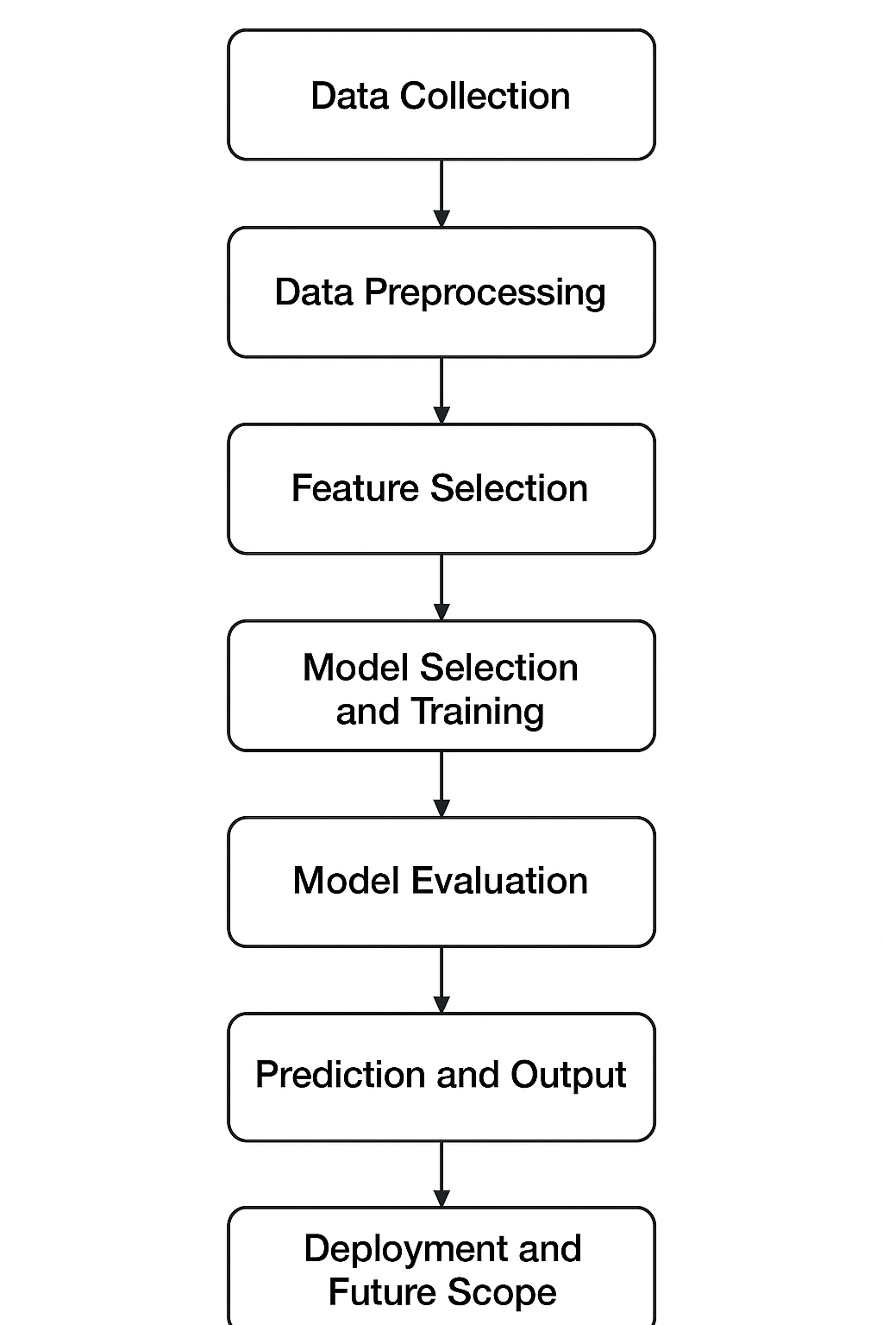
Methodology

Materials and method This project is based on the approach that explains how to create a stroke prediction model which uses machine learning through StrokeGuard system. Primarily, a system is to be developed which may determine whether or not a person will get stroke with few years in the future based on his health related features. The procedure consists of various key steps: data gathering, pre-processing, model choosing and training. All of them contribute to the precision and robustness of the system.

1.Data Collection
The process of data collection is the first step in our approach. In this paper, we use the Kaggle Stroke Prediction Dataset which is also a widely adopted dataset for stroke related research. It covers the health related information about more than 5,000 record entries of stroke and no stroke examples. It consists of a number of features (by name) such as age, sex, hypertension, heart disease (mi), body mass index (bmi), glucose level, smoking statis and cage type.
They are good indicators for prediction of stroke. For example, a person with high blood pressure or diabetes is more likely to suffer from a stroke if they’re in normal health The one-hot encoded data provides a balanced mixture of medical risk factors and lifestyle features that the model can learn from.

2.Data Preprocessing
Prior to feeding the data into our model, we pre-process it so that it is clean, coherent and analysis-ready. Missing values, noise, and errors are all possible in real-world datasets and are things that may hamper the performance of a model.
The preprocessing steps include:
Missing Value Treatment: Certain data may particularly be incomplete (e.g., absence of BMI or Glucose). Missing data are imputed with the mean or median of non-missing values.
Removing Duplicates and Errors Duplicate or irrelevant instances are eliminated so the model can extract accurate, unique information.
Label Encoding or One-Hot-Encode: Since machine learning models can only interpret the numerical data, we convert features like gender, work type and smoking status in text into numeric using label encoding or one hot encoding.
Normalization of Data: We normalize data to be within the same range for continuous features such as age, BMI and glucose. This in turn guarantees that there are no single features which dominate the model during training.
Balancing the Dataset - As there are significantly higher number non-stroke cases than stroke in our dataset, we have an imbalanced dataset. To overcome this, we apply methods such as SMOTE(Synthetic Minority Over-sampling Technique) to balance the stroke cases where the model can learn effectively.
In this way, by improving the prediction model’s accuracy and fairness.

3.Feature Selection
The selection of features is to find the critical elements that affect stroke risk. The different features do not all make the same contribution to the prediction. This observation can be explained as, some of the features such as age, hypertension and average glucose level has more effect with respect to others like work-type.
We want to employ correlation analysis and feature importance scores the attributes that have a significant relation with stroke. However, by retaining only the most informative features, we can remove noise that is present in our data and make the model easier to train and more efficient.

4.Model Selection and Training
You will now train the machine learning models on the preprocessed and feature selected text data. In this project we try different algorithms to see which one performs best. The models used include:
Decision Tree Classifier – This is a basic model that breaks down data into smaller and more manageable parts by applying decision rules. It's simple and easy to get.
Random Forest Classifier: A more sophisticated model that utilizes several Decision Trees in order to increase accuracy and minimize overfitting.
Support Vector Machine (SVM): A strong model, which separates stroke and non-stoke observations in the dataset with the best boundary.
We split the dataset into training data and testing data. The models are trained on the training data and then evaluated on the testing data to see how well they can predict examples that are new (unseen so far).

5.Model Evaluation
After the models have been trained, they are tested with different performance evaluation metrics to measure how accurate and trustworthy they are. The main metrics used are:
Accuracy: It is proportion of True Positives and True Negatives to whole data in population.
Precision: Indicates out of stroke cases predicted how many are accurate.
Recall (Sensitivity): Describes how many real stroke events that have been predicted by the model.
F1-Score: It is the harmonic mean of precision and recall for better comparision.
The Random Forest Classifier is the best-performing classifier overall. It is also effective when it comes to complex datasets, and manages both numerical as well as categorical features efficiently.
6.Prediction and Output
Once a model is complete, it can then be used to perform predictions. The system processes the information input pasted from a user, including their health (age, BMI, glucose level) and whether they smoke but not former smokers, to predict if the person is at risk of having a stroke.
The output is presented in an easy to read format. Eventually, one can hook this system up to a user interface (think: web or mobile app), and allow users to enter their details there for instant predictions.

7.Deployment and Future Scope
The last part of the process is to get our model ready for deployment. While this project is primarily concerned with model building, the model can be used in an app at a later stage.
In the next steps, StrokeGuard can be developed as web-application that both users and health providers able to access conveniently. The model can also be continuously refreshed with more medical data for better accuracy and to account for changing health trends.
To sum up, the method guarantees a full well-structured process from data collecting to prediction and is therefore practical and useful for StrokeGuard in real medical applications.

RESULTS

Once we prepared and cleaned the dataset, we applied various machine-learning models to determine which one could most accurately predict the likelihood of a stroke. Models such as Logistic Regression, Random Forest, SVM and Gradient Boosting were trained and compared.
Of them, our best performing model was the Random Forest model which gave us the highest accuracy and a more balanced set of predictions. It could properly identify those at risk of a stroke and not.
And when we looked at which features influenced it the most, age, hypertension, heart disease and average glucose level along with BMI came out as very important. Such findings correspond to those commonly observed in medical practices, which confirms the outputs of the model.
In general, the findings suggest that machine-learning models can aid in early prediction of stroke risk and possibly help make better decisions in health care.
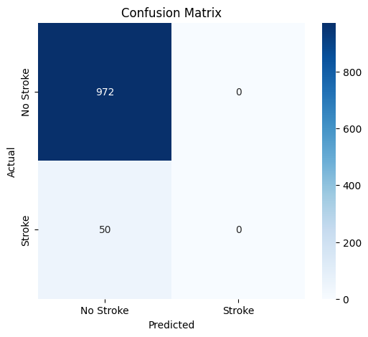
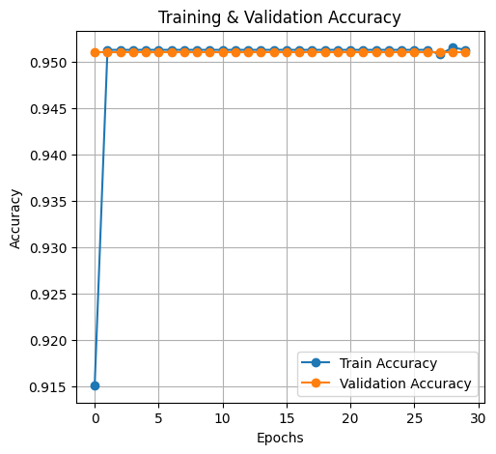
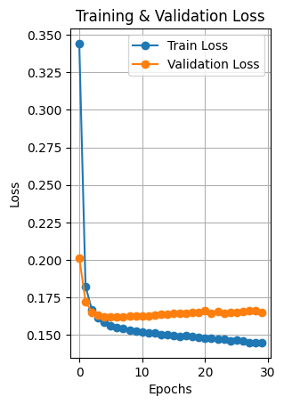

References
[1]Feigin, V. L., et al. (2014). Global and Regional Burden of Stroke 1990–2010. The Lancet.
[2]Wolf, P. A., et al. (1991). Atrial Fibrillation as an Independent Risk Factor for Stroke. Stroke Journal.
[3]Kononenko, I. (2001). Machine Learning for Medical Diagnosis. Artificial Intelligence in Medicine.
[4]Esteva, A., et al. (2017). Dermatologist-Level Classification Using Deep Neural Networks. Nature.
[5]Chen, X., et al. (2017). Decision Tree Models for Healthcare Risk Prediction. IEEE Access.
[6]Mohan, S., et al. (2019). Stroke Prediction Using Machine Learning Algorithms. IJCA.
[7]Ali, L., et al. (2021). Stroke Prediction Model Based on Deep Learning. Healthcare Informatics Research.
[8]Lee, J., et al. (2024). Interpretable Stroke Prediction with XGBoost and SHAP. JCNR.
[9]Benseñor, I. M., et al. (2001). Prevalence of Stroke in Developing Countries. International Journal of Epidemiology.
[10]Joo, S. H., et al. (2015). Data Quality and Model Performance in Health Prediction. BioMed Research.

